ORCHID INTERNATIONAL COLLEGE
SET A
Bijayachowk, Gaushala-9, Kathmandu
Full Marks: 60
Time: 3Hrs
Pre-Board Examination - 2080
BIM /Third Semester / IT 238: Data Structure and Algorithms

Candidates are required to answer the question in their own words as far as practicable.

Group "A"
Short Answer Questions: [10 × 1= 10]
- What is a data structure?
- Define hashing.
- Mention the drawback of linear queue. Write possible solution.
- What are the elementary sorting algorithms?
- Define tail recursion.
- Which data structures are used for BFS and DFS?
- Define expression tree.
- What is a cut vertex?
- What is a linked list?
- How is bubble sort implemented?

Group "B"
Exercise Problems: [5 ×3 = 15]
- Write a java program to find nth term of Fibonacci series using recursive function.
- Write java function for pre order traversal in a BST.
- Write a java program to sort the data using Bubble sort algorithm.
- Evaluate the given postfix expression.
5 2 1 * + 3 –
- Write algorithm for enqueue operation in a simple queue.

Group "C"
Comprehensive Answer Questions: [3 × 5 =15]
- For the given string apply Huffman encoding and calculate the reduced size of the string.

BCAADDDCCACACAC

- Write a java function to insert a node at the specified position of a singly linked list.
- Insert keys {99, 28, 39, 18, 19} with the hash table of size 10 using Quadratic Probing

Group "D"
Long Answer Questions: [2 × 10 =20]
- What is AVL tree? Why do we need it? Explain the rotation techniques in an AVL tree.
Construct a B-tree of order 5 from the given data [1+1+4+4]
2, 8, 7, 3, 12, 5, 9, 14, 6, 20, 10, 19, 25, 17, 15, 13, 1, 18

- What is a minimum spanning tree? Which algorithms are used for finding minimum spanning tree? Explain Kruskal’s algorithm with a suitable example. What is Dijkstra’s algorithm used for? In the given graph, use the source vertex as “0” and find the shortest path using Dijkstra’s algorithm.
[1+1+3+1+4]

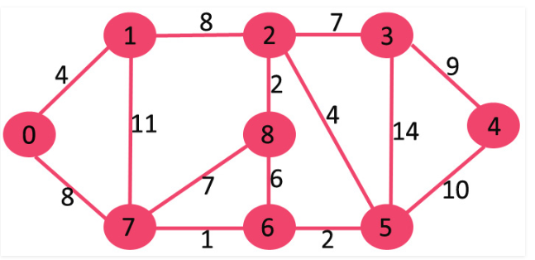

ORCHID INTERNATIONAL COLLEGE
SET B
Bijayachowk, Gaushala-9, Kathmandu
Full Marks: 60
Time: 3Hrs
Pre-Board Examination - 2080
BIM /Third Semester / IT 238: Data Structure and Algorithms

Candidates are required to answer the question in their own words as far as practicable.
Group "A"
Short Answer Questions: [10 × 1= 10]
- Define hash table.
- What do you mean by tail recursion?
- What is a spanning tree?
- What is tree traversal? What are its types?
- How is selection sort implemented?
- Define B tree.
- What is a cut edge?
- Define Balance Factor.
- How is a linear data structure different from non-linear data structure?
- What is logarithmic complexity?

Group "B"
Exercise Problems: [5 ×3 = 15]
- Write a java program to find factorial of a number using recursive function.
- Write java function for post order traversal in a BST.
- Write a java program to sort the data using Selection sort algorithm.
- Evaluate the given prefix expression.
* + 4 / 8 4 3
- Write down the algorithm for push operation in a stack

Group "C"
Comprehensive Answer Questions: [3 × 5 =15]
- For the given string apply Huffman encoding and calculate the reduced size of the string.

BCAADDDCCACACAC

- Write a java function to insert a node at the specified position of a doubly linked list.
- Insert keys {99, 28, 39, 18, 19} in the hash table of size 10 using Double Hashing.

Group "D"
Long Answer Questions: [2 × 10 =20]

- Explain the steps to delete a node from a B Tree with suitable figures. Create a max heap from the given data. [6+4]
20 22 33 44 12 15 18 19 17 9 25

- Write algorithm for topological sorting and illustrate it with a suitable example. From the given graph use Warshall Floyd algorithm to find the shortest path from each vertex to every other vertices.
[5+5]
